CRUD Operations for E-Commerce Product Management System

1. Title
CRUD Operations in E-Commerce Product Management System

2. Objective
The purpose of this task is to demonstrate the four basic CRUD operations using the Product table in the E-Commerce Database.
CRUD represents:
- C – Create: Inserting a new product into the table
- R – Read: Retrieving and viewing product information
- U – Update: Changing the details of an existing product
- D – Delete: Removing a product from the table

3. Database Used
Database Name: ecommerceD__B;
All CRUD operations are carried out using the Product table.

4. Create Operation
The Create operation is used to insert a new product into the Product table.
For this operation, a product named Smart Watch is added with its category, price, and available stock.

Product Details
Attribute | Value
Product Name | Smart Watch
Category ID | 1
Price | 4500
Stock Quantity | 25

SQL Query
INSERT INTO Product
(Product_Name, Category_ID, Price, Stock_Quantity)
VALUES
('Smart Watch', 1, 4500, 25);

Result
The Smart Watch record was successfully inserted into the Product table.
Screenshot:
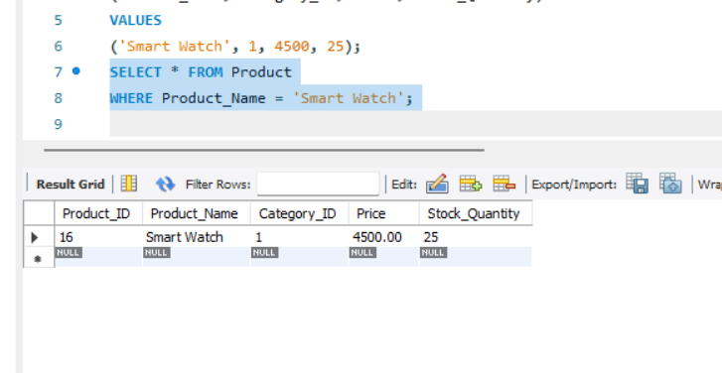

5. Read Operation
The Read operation is performed to retrieve and view the product records available in the Product table.

SQL Query
SELECT * FROM Product;

Result
All available product details were successfully retrieved from the Product table.
Screenshot:
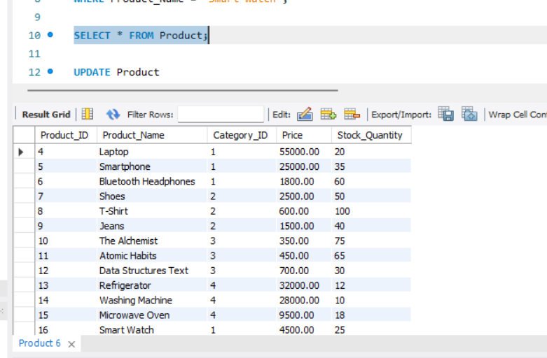

6. Update Operation – Laptop Price
The Update operation is used to modify the existing price of the Laptop.
The Laptop price is changed from 55000 to 58000.

SQL Query
UPDATE Product
SET Price = 58000
WHERE Product_Name = 'Laptop';

Verification Query
SELECT * FROM Product
WHERE Product_Name = 'Laptop';

Result
The Laptop price was successfully changed to 58000.
Screenshot:
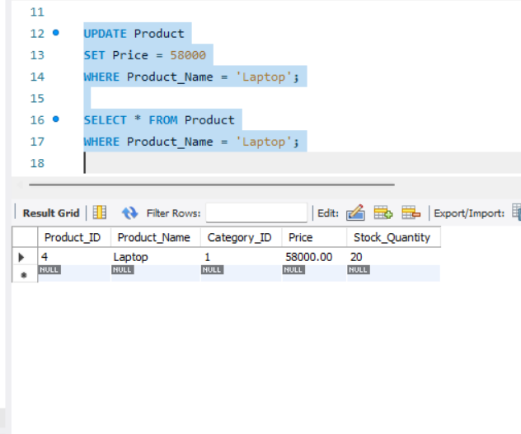

7. Update Operation – Laptop Stock
The stock quantity of the Laptop is increased by 15 units to represent an increase in available inventory.

SQL Query
UPDATE Product
SET Stock_Quantity = Stock_Quantity + 15
WHERE Product_Name = 'Laptop';

Verification Query
SELECT * FROM Product
WHERE Product_Name = 'Laptop';

Result
The Laptop stock quantity was successfully increased by 15 units.
Screenshot:
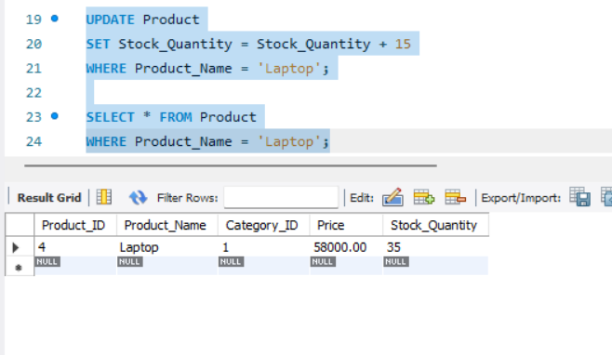

8. Update Operation – Shoes Stock
The stock quantity of the Shoes product is decreased by 2 units.
The condition ensures that the stock is reduced only when at least 2 units are available.

SQL Query
UPDATE Product
SET Stock_Quantity = Stock_Quantity - 2
WHERE Product_Name = 'Shoes'
AND Stock_Quantity >= 2;

Verification Query
SELECT * FROM Product
WHERE Product_Name = 'Shoes';

Result
The Shoes stock quantity was successfully reduced by 2 units.
Screenshot:
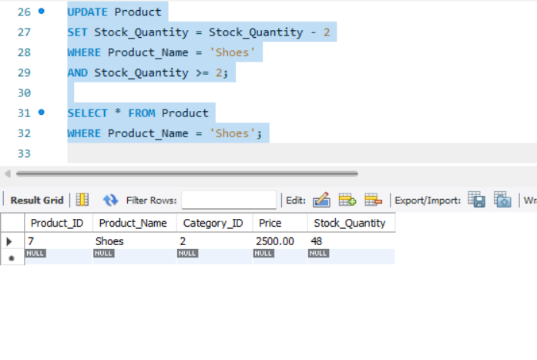

9. Delete Operation
The Delete operation is used to remove an unwanted product from the Product table.
In this operation, the Microwave Oven product is removed.

SQL Query
DELETE FROM Product
WHERE Product_Name = 'Microwave Oven';

Verification Query
SELECT * FROM Product
WHERE Product_Name = 'Microwave Oven';

Result
The Microwave Oven record was successfully removed from the Product table.
Screenshot:
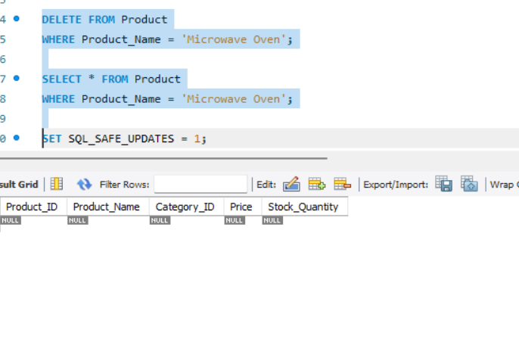

10. Final Result
The CRUD operations were successfully implemented on the Product table of the EcommerceDB database. The task demonstrated how to insert new products, retrieve existing records, modify product details, update inventory quantities, and delete unwanted products using SQL commands.

